COINS-Constantine I (306-337) AE3-320 CE- VICTORIAE LAETAE PRINC PERP

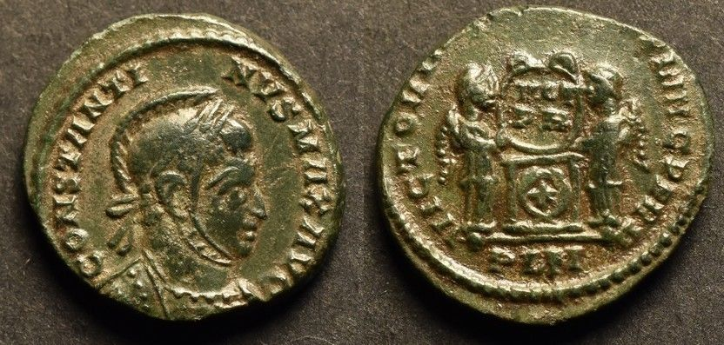

Constantine I AE3

                       Obverse: CONSTANTINVS MAX AVG - Laureate, helmeted and cuirassed bust of Constantine I.

                       Reverse: VICTORIAE LAETAE PRINC PERP - Two Victories, holding shield inscribed VOT / PR above altar, PLN in ex. (London mint).

                       Date: 320 AD

                       Diameter: 17.94 mm.

                       Weight: 3.19 gr.

                       References: RIC 170 (rated r2)

                       Characteristics: